Breezy Karaoke (Call Coach)

## What we do

We’re building the first and last employee that any solo service pros will need to run their business, starting with a business phone number + AI frontdesk that can handle inbound/outbound calls + text messages to customers across their entire lifecycle. We have hundreds of customers ranging from verticals like home services, instructors, consultants and professional services. We believe in a world where millions of people can offer their services and grow their business without needing to grow headcount for operational work. We recently raised millions of dollars from top vcs, as well as some key openai employees (chief product officer, chief technical advisor to ceo, head of bd) and are looking to grow.

## Why Breezy Karaoke

Here’s the thing. Breezy already offers two distinct life-choices for a phone call:  
 **(a) Autopilot,** where the AI answers, charms the prospect, and emails you a neat transcript; and  
 **(b) Manual,** where you do the talking while Breezy quietly types like a Victorian stenographer.¹

This project is about juicing option (b). We are going full Dr. Frankenstein and wiring an LLM straight into the call *while it’s happening*. Think of it as the world’s smartest, most introverted co-pilot whispering: “Hey, you forgot to mention the price” or “Maybe don’t say ‘synergy’ again.”

What does this actually mean:

1. **Memory:** Reminds the user important details / action items from previous conversations, emails, etc
2. **Goals:** Helps the user stay on track for the conversation / hit all the goals

Let’s take our users from “mediocre conversationalist who vaguely recalls a podcast about active listening” to “terrifyingly competent closer who knows every follow-up action before the prospect finishes talking”

Current State of the world

Currently, in the in-call experience. We provide live transcripts of the conversation. Not a very useful in-call experience but can be a basis for something more advanced.

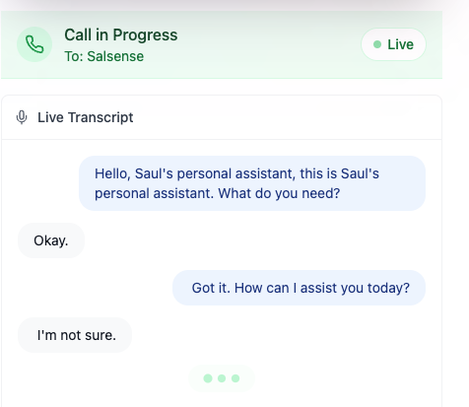

|  | **Path** |
| --- | --- |
| Frontend component | breezy-fe/components/phone_calls/LiveCallView.tsx |
| Backend Live transcripts | socratic_systems/app/actions/phone_calls/outbound_web_call_action.rb |

## Breezy Karaoke - Phases

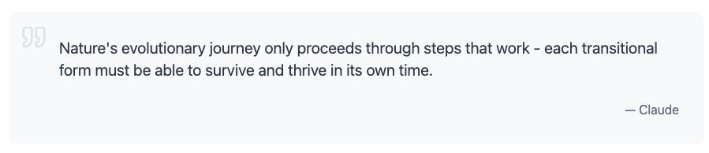

The above is equally true for product development. Each “phase” of the product should provide value to the users. Breaking product development into phases allows us to “close the loop” and quickly get feedback from users. Ensuring that we generate maximal value to our users. This is a tentative outline for the project:

**Phase 1: Karaoke**

Make suggestions in real time from the transcript of the call. The suggestions should be really concise and readable. The suggestions should be “explainable”, like the LLM should output a reason for why it made the suggestion (that the user could review after / during the call). These suggestions shouldn’t be time sensitive. The UX should be “big”. Like big letters that are easily readable. The UX should be usable by someone who just had six beers.

**Phase 2: Call Report**

After the call, we should analyze which of our suggestions was followed by the user. We should analyze which suggestions we should have probably made but failed to. This information should be displayable to the user after the call, but it’s mostly for us to monitor the performance and iterate on the system.

**Phase 3: Personalized**

We should give the user an ability to personalize their call coach. Not sure what it looks like. Maybe a bunch of rules or an SOP or something. After long calls, we can ask for feedback and use that potentially. Make a simple UX for this.

**Phase 4: Close the loop**

We should use the information from the call reports to do some automatic personalization. Use a reasoning model to refine the “SOP” basically.

**Phase 5: Precall guidance**

Before calls if the user chooses to, the coach and the user can have a quick discussion on the high level goals of the conversation so they are in agreement on how to approach this. Potential for a lot of UX experiments here.

**Phase 6: Experimental UX**

Not really sure what this looks like exactly. I like the idea of a checklist sort of UX that gets checked, but I think in general we have a lot of leverage to make interesting things here.

## Science Fiction Inspiration [The exocortex from accelerando](https://en.wikipedia.org/wiki/Accelerando) [The Whispering Earring](https://croissanthology.com/earring) [The Truth of Fact, the Truth of Feeling](https://archive.org/details/ted-chiang-the-truth-of-fact-the-truth-of-feeling)

## Design Inspiration (/Competitors)

| **Competitor / Inspiration** | **Screenshot** |
| --- | --- |
| [Cresta Realtime](https://cresta.com/cresta-agent-assist/) |  |
| [Balto Real Time agent assist](https://www.balto.ai/real-time-agent-assist/) |  |